***Experiment 8***

***AIM:*** To migrate from MySQL to Amazon RDS with AWS DMS.

***PROCEDURE:***

1. Go to Amazon RDS console and select “Create database”.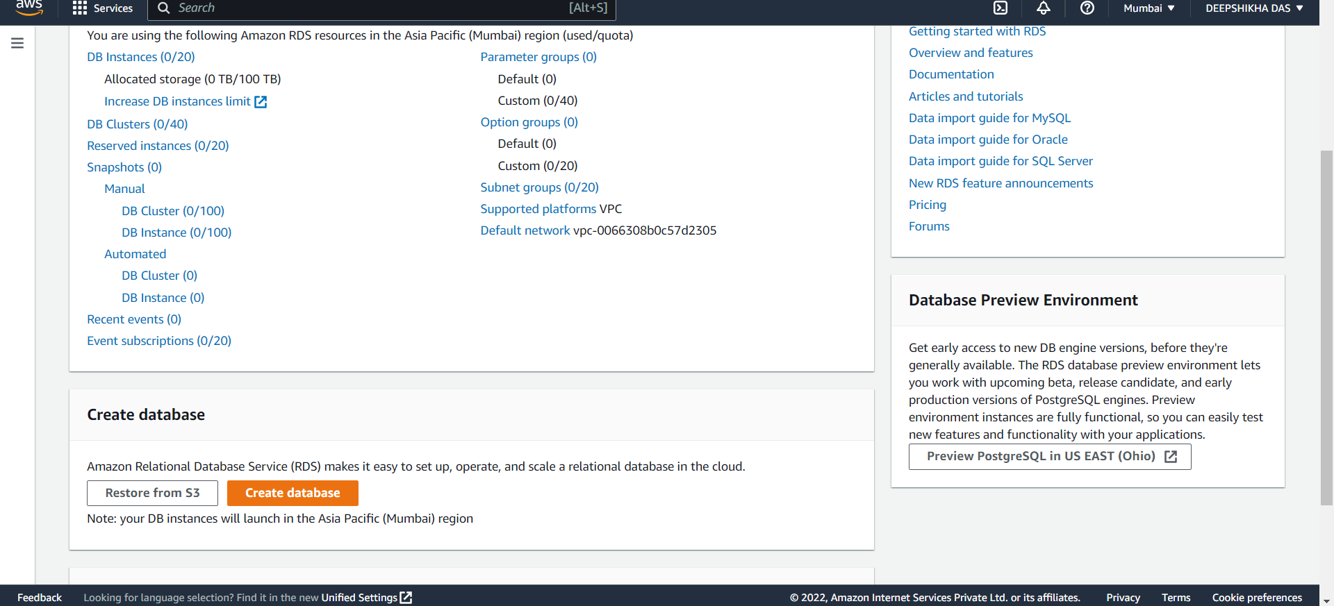
2. Select MySQL engine as engine type in the “Create database page”.

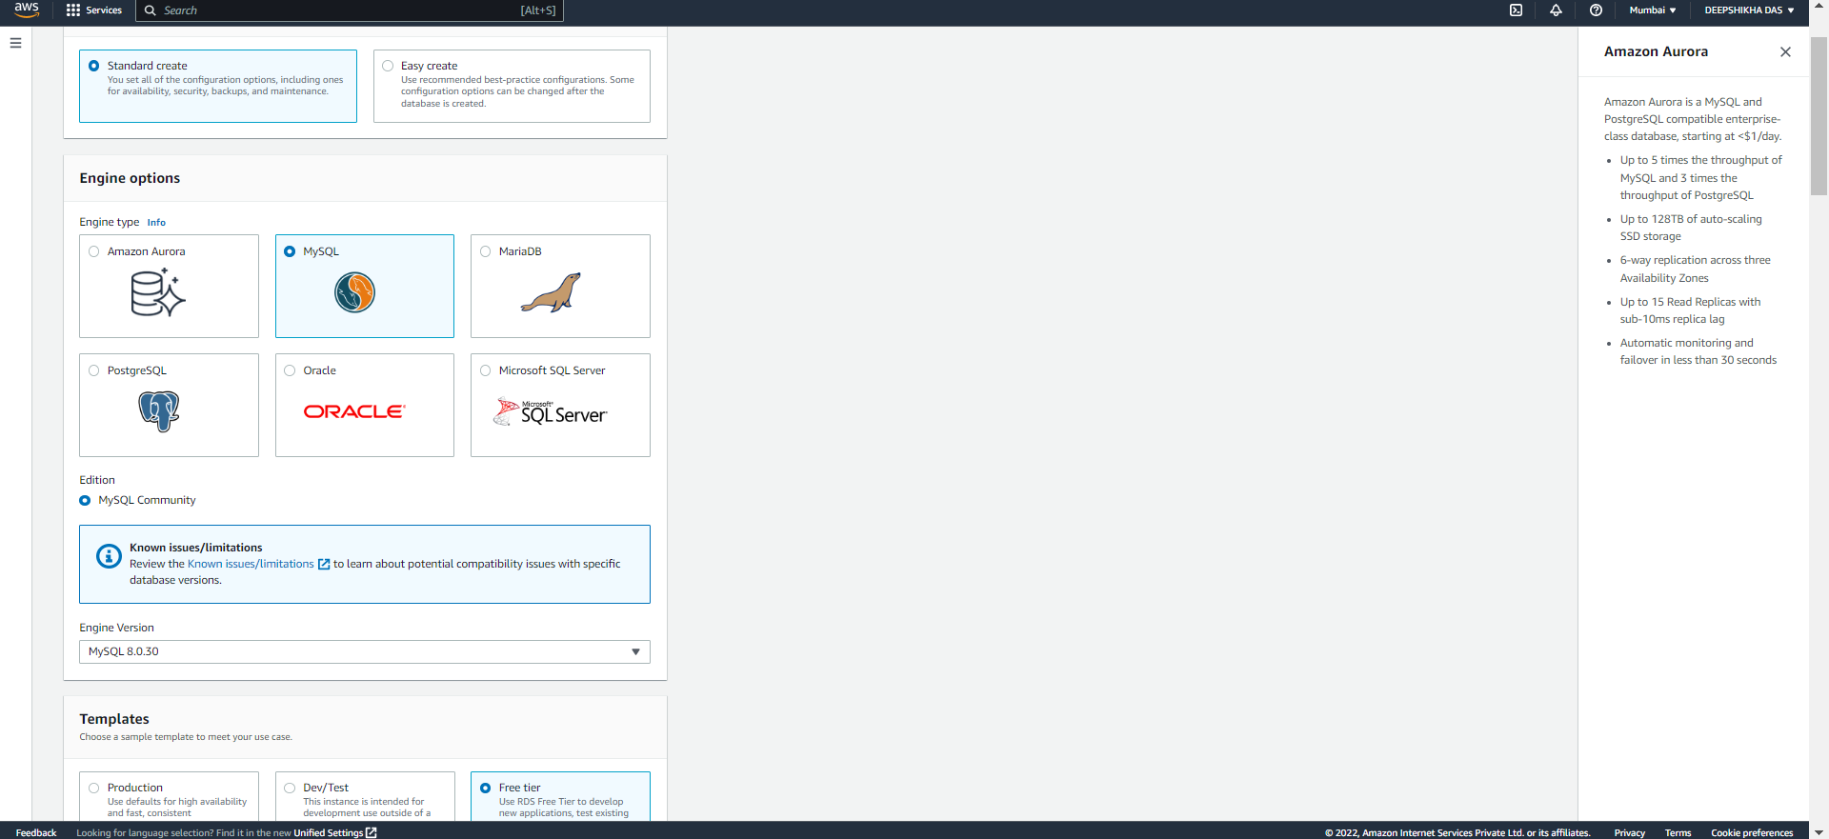

1. Click on “Free Tier” as templates and leave other configurations as it is.
2. Create a Master username and password and remember that for future use.
3. Go to AWS DMS console page and click on “Create Replication Instance”. Choose the name for your instance and select “t3.micro” in instance class. Select the vpc you want your instance to be in and select “Dev or test workload.

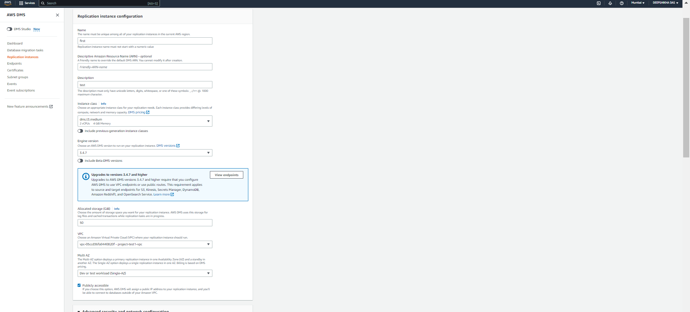

1. Go to “Security Groups” in EC2 console. Click on your security group name and click on “edit inbound rules”. Select “MYSQL/Aurora” in type and select the security group of your instance, in this case default and click on “save rules”.

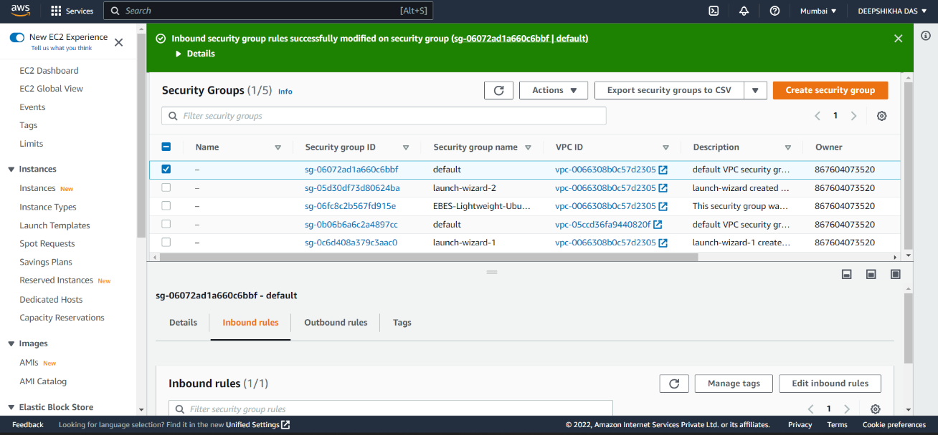

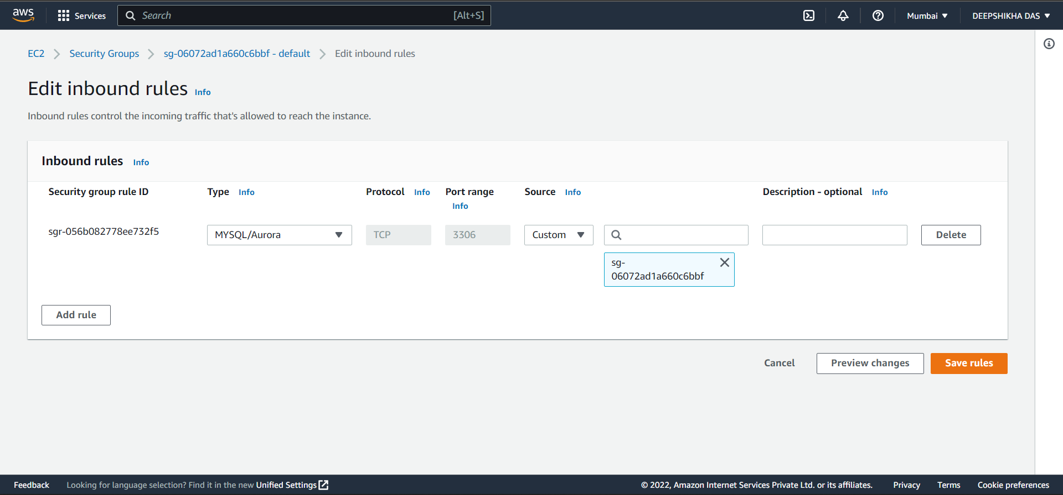

1. Go to AWS DMS console and to the endpoints page and click on “Create Endpoint”.

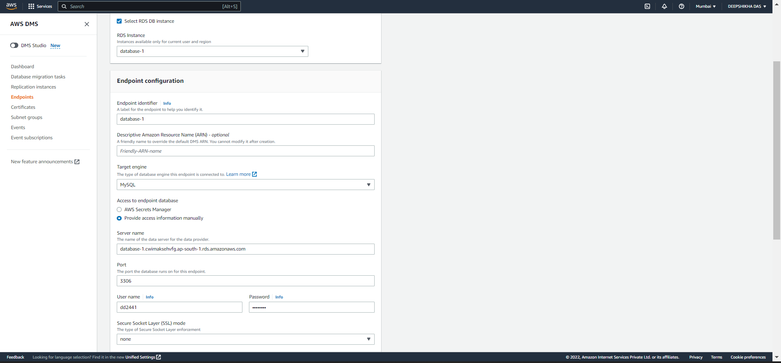

1. Repeat the above steps for “Source Endpoint” except do not check the “select RDS DB instance” and choose a different name for endpoint identifier.

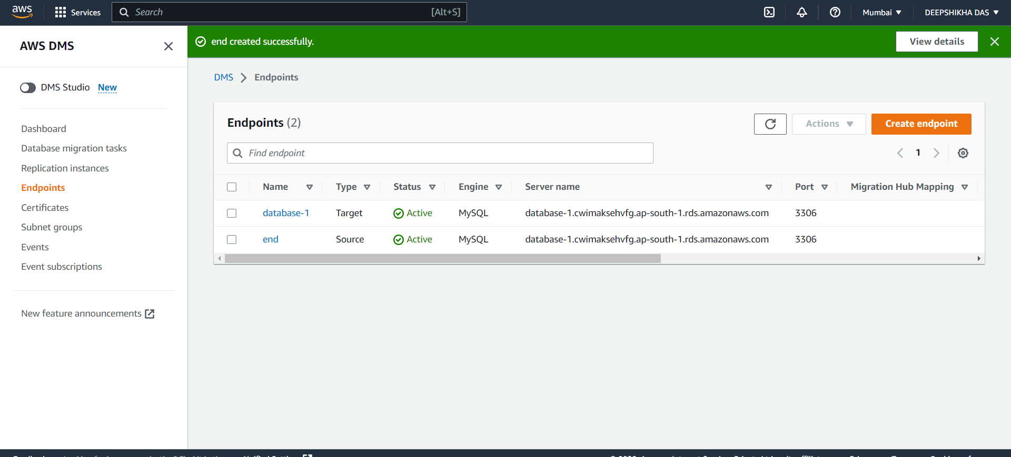

1. Click on “Add new selection rule”, enter a source name- it can be anything and put “%” in table name. Finally click on “create task”

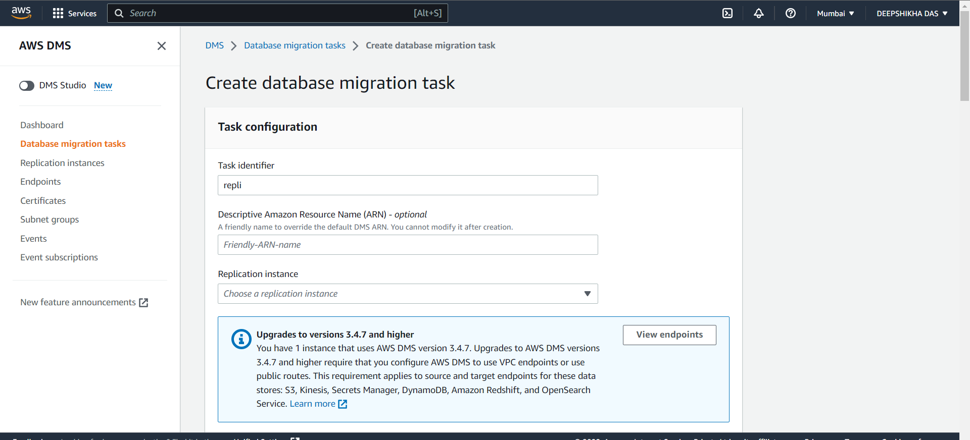

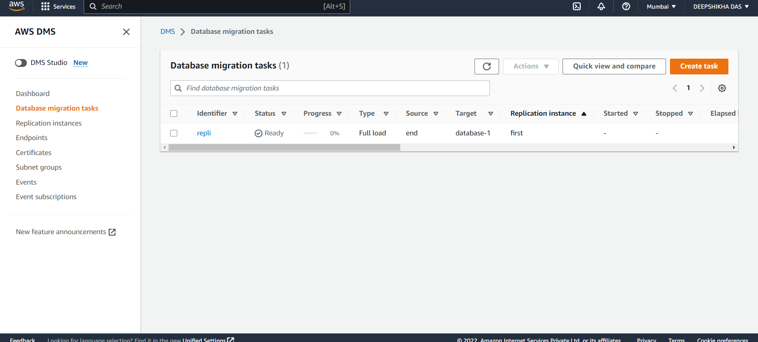

***RESULT:*** A MySQL database was migrated to Amazon RDS with the help of AWS DMS.